**Movie Testure plus Interactivity**

Tests for playing movies plus interactiivty such as Stop, Pause, and (Re)Start. Also switch the movies, go to a specific frame. All movies were created for Samsung and are property of Samsung.

**MovieTexture01.x3d**

Basic movie on a plane, no interactivity. Primitives lifted before and after the movie mesh in the X3D file.

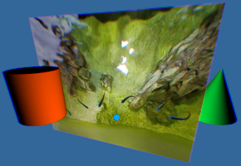

**MovieTexture_primitive.x3d**

Each primitive (Box, Cone, Cylinder Sphere) is rotated and plays a movie. The red and green panels around the Cylinder are just there to show the object is rotated. There is also a flat plane at the end of the file playing another movie. Note: this demo runs really slow and may halt the phone.

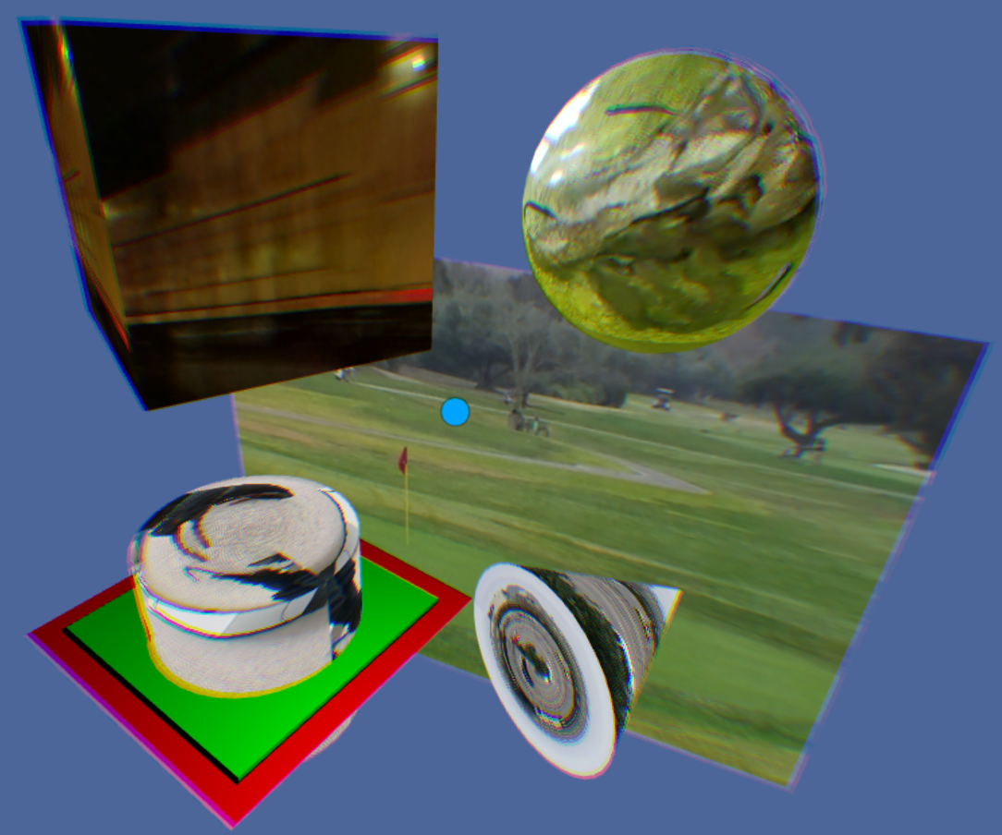

**MovieTexture_teapot.x3d**

Movie playing on a rotating teapot next to the same shared rotating teapot mesh with a simple texture.

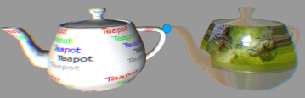

**MovieTexture_MultipleMovies.x3d**

4 separate movies playing on their own plane. A few primitives to vary the demo.

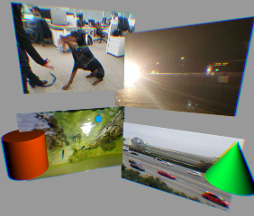

**MovieTextureChange.x3d**

Following the opening movie, then rolling over the each primitive changes the movie playing, and the color of the other primitive.

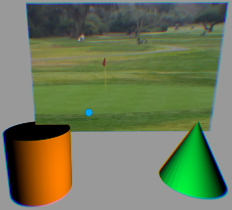

Rolling over the Cone changes the Cylinder from orange to yellow and changes to the Bayshore Freeway movie. Rolling over the Cylinder changes the Cone from green to blue and changes to the fish movie.

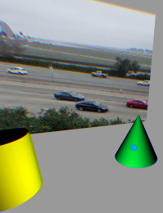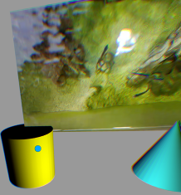

**MovieTexture_StopStartPause.x3d**

Movie of CalTrain street crossing can be paused and (Re)Started where it left off, or Stopped and (Re)Start at the beginning.

.

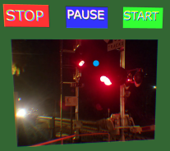

**MovieTexture_PitchSpeed4x.x3d**

CalTrain movie can run at 4x speed, or resume normal speed. Note that at 4x speed, it doesn’t speed up the movie as much as it feels like it jumps ahead.

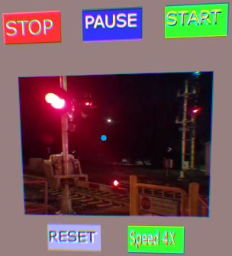

**MovieTexture_PitchSpeed.x3d**

Caltrain movie can double speed each rollover of “+ Speed” and halve the speed each time rolling over “- Speed”. And resets to normal rolling over “RESET”.

A doubling of speed does indeed run it fast. Byeond doubling feels more like it jumps. Slowing down feels and sounds slowed down.

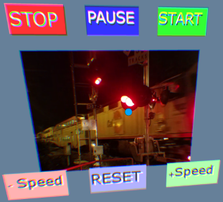

**MovieTexture_GotoFrame.x3d**

Lower buttons go to either the mid-point (Half-way) of the movie, or to frame 33,000 “Go to A” button.

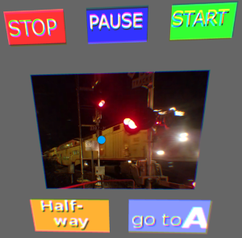

**MovieTexture_SliderBar.x3d**

The Caltrain movie is about 61 seconds (61000 milliseconds) long. The train begins around millisec 32000, and ends around millisec 47000. The dull yellow slider bar movies in sequence to the current frame (in 3d space, it is from -4 to +4 along the x-axis).

Rolling over the yellow ‘slider’ box highlights the box to a brighter yellow, and dragging left / right will change the current millisecond on the movie. Moving up / down ends the dragging and returns the box back to a dull yellow.

